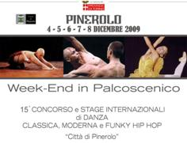
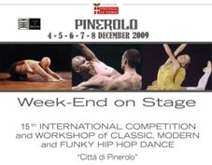
APPLICATION FORM
15° INTERNATIONAL COMPETITION OF CLASSICAL, MODERN AND HIP-HOP DANCE
“CITTA’ DI PINEROLO””
(to send filled in each part for the registration and also give a copy to the reception during the competition)

□ CLASSICAL SECTION □ Soloists Baby □ Soloists Children □ Soloists Juniores □ Pas de deux □ Junior Groups □ Open Groups □ Open Gr. amateurs
□ MODERN SECTION □ Soloists Baby □ Soloists Juniores □ Soloists Seniores □ Pas de deux □ Junior Groups □ Open Groups □ Open Gr. amateurs
□ HIP-HOP SECTION □ Junior Groups □ Open Groups □ Open Groups amateurs
□ EMERGING COMPANIES SECTION

SCHOOL OF DANCE _____________________________________________ Representative ___________________________N.I.NUM. / VAT NUMBER___________________
Address_________________________________________ City ______________________ Postcode ________Cell _________________ E-mail _______________________

Choreographer/Teacher _______________________________________________
Address _____________________________________________ City____________________ Postcode _______ Cell _________________ E-mail ______________________
Interpreter__________________________________________ Date of Birth __________________ N.I. NUMBER _____________________________
Address _____________________________________________ City____________________ Postcode ________ Cell _______________ E-mail _______________________
(For groups fill the data for all the components)

PROGRAMS
□ Classical Sect. □ Soloist □ Pas de deux
Title I Variation ____________________________Choreographer ________________________________ Piece’s Author________________________ Duration ______
Title II Variation( only juniores)___________________ Choreographer ________________________________ Piece’s Author _______________________Duration______
□ Classical Section □ Groups □ Modern Section □ Soloists □ Pas de deux □ Groups □ Hip-Hop Section □ Groups □ Emerging Companies
Choreography title ____________________________Choreographer _________________________________ Title of music piece________________________________
Author of piece __________________________ Duration____

I accept the competition rules and assert that all candidates have complied law requirements on health preservation.

Signature of the candidate or responsible’s group Signature of the choreographer or teacher Signature of the school director

__________________________________________ _______________________________________ ______________________________________
ATTACHED: documentation admission fee at Cultural Association Body Show by □ postal account n. 56712995 □ postal order □ bank draft IBAN IT04D0200830750000040260406
copy of the identity document
consent of a parent for candidates under the age of 18

